4.80

4.91



5.1

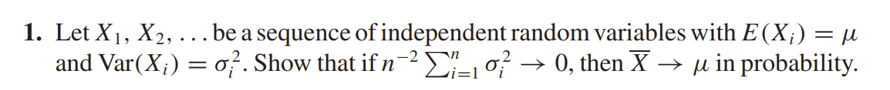

5.10

5.16

5.23

[R problem] 5.30

